KANSAS COMMUNITY EMPOWERMENT FOLIO
Community of Action
When complete, submit to KSCE@ksu.edu

About Community of Action:
Communities of Action are Year II communities, although most have participated in the program for many years and are the maintainers and sustainers of the KCE Program. Communities of Action generally have standing projects, although may consider new projects, and potentially aspire to attain the designation of Community of Excellence.

The purpose of this folio is to:
- To add educational components that result in capacity building within your organization and its members
- Help you keep a history of what you have worked on during your participation in the program
- Help guide you through community assessment if your community is interested
- Assist you in keeping track of your year of work
- Serve as a document for an easier succession transition

FOLIO:

To be eligible for awards, Communities of Action must include this folio as a part of their awards request (Only one form needs to be submitted to be eligible for awards, not one per award application). To apply for awards, Communities of Action must work through the following tasks:

Basics:
Name of Community
Enrolled | Type Yes or No
Submitted Resolution | Resolution Number
Quarterly Reports Submitted | Type Yes or No

Education (Can be acquired on the KCE Website Education Page. The more you complete the stronger your application review score will be):
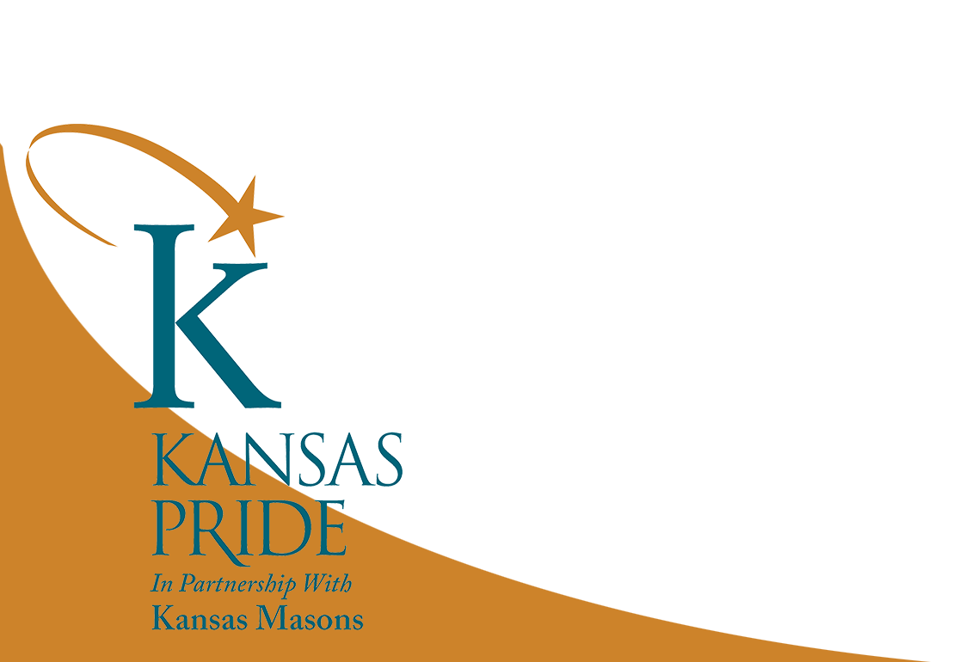
Module | Date Completed | By Who/How Many Viewed
Introduction to the KCE Program (in person or online)
Enrolling in the KCE Program
Reporting System
Enrollment Levels, Recognition, and Awards
Engaging Your Community and Community Tools
KCE Toolkit Lesson 1: Getting Started
KCE Toolkit Lesson 2: Fiscal Responsibility
KCE Toolkit Lesson 3: Telling Your Story
KCE Toolkit Lesson 5: Volunteer Motivation and Maintenance
KCE Toolkit Lesson 6: Volunteer Nature

Extra Credit:
Module | Date Completed
Crowdfunding
Community of Action Grant Application Overview
Community Promotion Grant Application Overview
Trainings provided by K-State Research and Extension Local Unit
Kansas Department of Commerce Opportunities
Trainings from Kansas Volunteer Commission
Other Trainings

For advancing to Community of Excellence (Optional, only to be considered if the community applies for Community of Excellence):

Assessment | Date Completed
First Impressions Program
Youth Community Perceptions
Needs Assessment/Survey
K-State Research and Extension Grant Writing Workshop

This Folio must be included with your awards application and will be used to determine eligibility and readiness for awards of recognition or grants.

If you have any questions, or need guidance, please contact the KCE Office at KSCE@ksu.edu or 785.532.5840

Rev. 2023

