KANSAS COMMUNITY EMPOWERMENT FOLIO
Community of Growth
When complete, submit to KSCE@ksu.edu

About Community of Growth:
Communities of Growth are new, or re-forming, communities that need, or would appreciate, extra guidance and assistance through the initial stages of the program.

The purpose of this folio is to:
- To add educational components that result in capacity building within your organization and its members
- Help you keep a history of what you have worked on during your participation in the program
- Help guide you through community assessment if your community is interested
- Assist you in keeping track of your year of work
- Serve as a document for an easier succession transition

FOLIO:

To be eligible for awards, Communities of Growth must include this folio as a part of their awards request (Only one form needs to be submitted to be eligible for awards, not one per award application). To apply for awards, Communities of Growth must work through the following tasks:

Basics:
Name of Community
Enrolled | Type Yes or No
Submitted Resolution | Resolution Number
Quarterly Reports Submitted | Type Yes or No

Education Extra Credit (Can be acquired on the KCE Website Education Page. The more you complete the stronger your application review score will be):
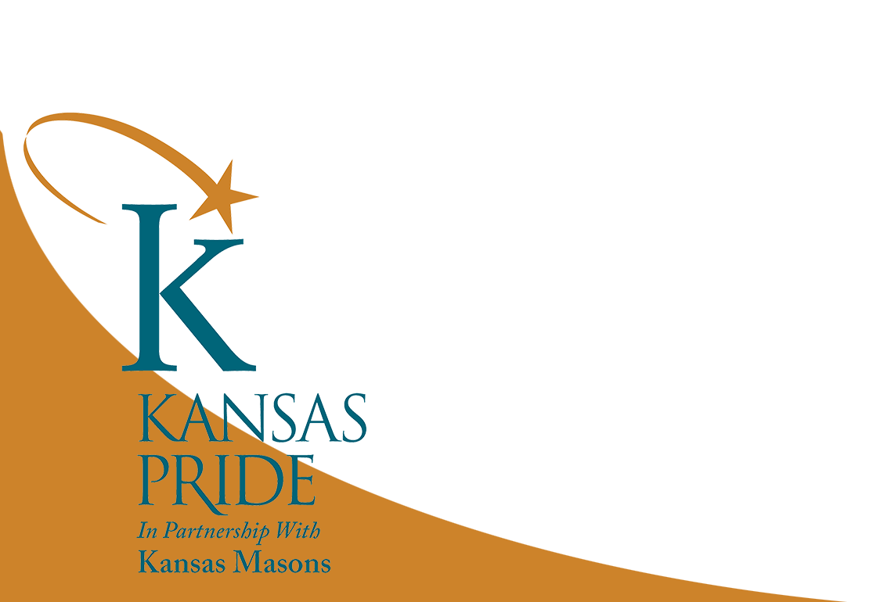
Module | Date Completed | By Who/How Many Viewed
Introduction to the KCE Program (in person or online)
Enrolling in the KCE Program
Reporting System
Enrollment Levels, Recognition, and Awards
Engaging Your Community and Community Tools
KCE Toolkit Lesson 1: Getting Started
KCE Toolkit Lesson 2: Fiscal Responsibility
KCE Toolkit Lesson 3: Telling Your Story
KCE Toolkit Lesson 5: Volunteer Motivation and Maintenance
KCE Toolkit Lesson 6: Volunteer Nature
Community of Growth Grant Application Overview

Additional Extra Credit:
Module | Date Completed
Crowdfunding
Rising Star Award Instructions
Trainings provided by K-State Research and Extension Local Unit
Kansas Department of Commerce Opportunities
Trainings from Kansas Volunteer Commission
Other Trainings

This Folio must be included with your awards application and will be used to determine eligibility and readiness for awards of recognition or grants.

If you have any questions, or need guidance, please contact the KCE Office at KSCE@ksu.edu or 785.532.5840

Rev. 2023

